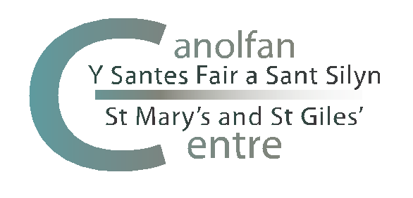

The St Mary’s Centre Annual Symposium
in Practical Theology and Religious Education
12-14 November 2019
at Noddfa, Penmaenmawr

BOOKING FORM
Name:
Address:
Post code:
Email:

ACCOMMODATION REQUIREMENTS
Please tick as applicable
Residential | £150.00
Non-residential (full Symposium) | £90.00
Non-residential 12 November 2019 | £45.00
Non-residential 13 November 2019 | £45.00
Non-residential 14 November 2019 | £20.00
Special requirements (e.g. dietary, ground floor room)

PAYMENT
Please tick as applicable
By bank transfer to:
Sort Code: 20-25-69
Account No: 63617513
Account Name: The St Mary’s and St Giles’ Centre
Please quote your name and ‘Symposium’ as a reference
By cheque for £…. (made payable to ‘The St Mary’s and St Giles’ Centre’)
Please forward with completed booking form to:
Mrs Emma L. Eccles, The St Mary’s Centre, Llys Onnen, Abergwyngregyn, Llanfairfechan, Gwynedd LL33 0LD

PRESENTATION
Please tick as applicable
I will not be making a presentation at the Symposium
I will be making a presentation at the Symposium (1 hour)
I will be making a presentation at the Symposium (30 minutes)

Please return this booking as soon as possible and by 30 September 2019 at the latest:
- by email (if payment to be made by bank transfer) to emma.eccles@bishopg.ac.uk
- by post (if payment made by cheque) to Mrs Emma L. Eccles, The St Mary’s Centre, Llys Onnen, Abergwyngregyn, Llanfairfechan, Gwynedd LL33 0LD

